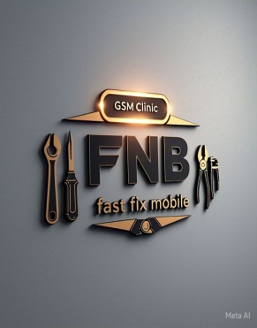

**FNB FAST FIX MOBILES**

**………G.S.M CLINIC……...**

**OUR VISION**

At FNB Fast Fix Mobile our vision is to be the trusted go-to destination for fast, reliable, affordable mobile device repairs and we are committed to delivering lightning-fast professional mobile repairs that exceed our customers’ expectations.

**OUR MISSION**

FNB Fast Fix Mobiles aims to simplify mobile device repairs by offering convenient, affordable, efficient solution and fostering a culture of excellence, integrity and customer satisfactions

**OUR CORE VALUES**

At FNB Fast Fix Mobile we are guided by the following core values. Customers first, quality matters, speed and efficiency, integrity and transparency and continues improvement

EMAIL ADDRESS: [freemanbature22@gmail.com](mailto:freemanbature22@gmail.com)

PHONE: 0708 388 8140

**NAMES OF COMPETTITORS AND THERE SERVICES**

**SLOT:** They all type of repairs but focus more on hardware repairs and they target only rich customers.

**NEXTIME MOBILES:** They all type of repairs but focus more on hardware repairs and they target only rich customers too.

**MANI G. COMMUNICATION LT**.: They do only hardware and sells of phones parts but their target are the middle class.

**CHITEX COMMUNICATION:** They focus only on software and their customers are the middle class too.

**ADVANTAGE OF FNB FAST FIX MOBILES OVER THEM**

* **We at fast fix mobile deals on both soft and hard ware repairs**
* **We will offer an easy fix policy**
* **We will offer customer maintenance**